Object Model
Food Cart Tracker
TBD



Submitted By: Victor Jellesed
Submitted To: Calvin Caldwell
E-mail: victor.jellesed@oit.edu
Date: 11/10/16
Version 1.0

Signatory Page

This document accepted by:

______________________________ _____________
Signature (Calvin Caldwell) Date

This document submitted by:

______________________________ _____________
Signature (Clint Jellesed) Date

Revision History
Author | Company | Version | Date | File Name | Comments
Jellesed | TBD | 1.0 | 11/10/16 | Object Model | First Draft

Contents
2. Signatory Page 2
3. Revision History 3
4. Class Diagrams 4
4a Executive 4
4b Detailed 5
5. Class Specifications 6
6. Updated CRUD Matrix 22

Class Diagrams

4a Executive
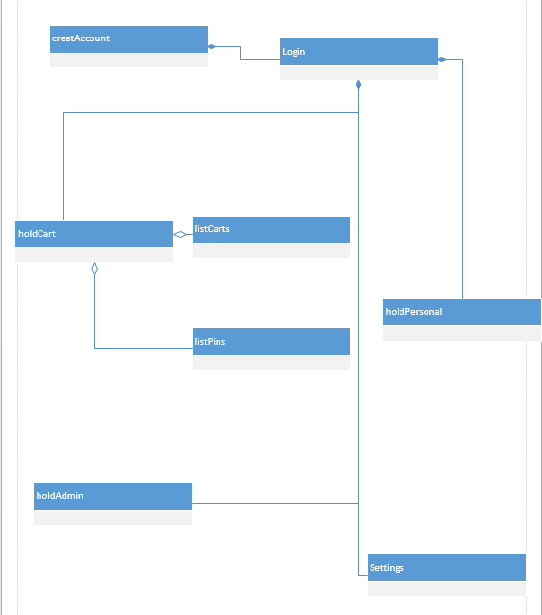

4b Detailed
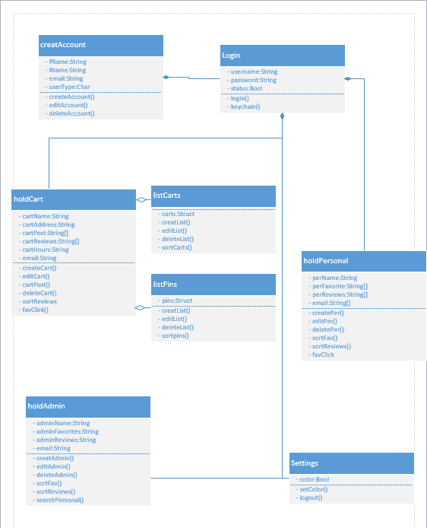

Class Specifications

Class Information

Class Name: createAccount

Abstract Type: No Persistence: Yes

Trace-ability Information
Use Case ID | Use Case Name | Steps
28 | Create Account | Called on step 5

Public Methods
Signature | Preconditions | Post Conditions
deleteAccount() | User goes to the settings page and clicks delete account. | All information is removed from the database and the email is freed up.
editAccount() | User clicks edit on his personal page. All information fields become editable text boxes. | User has changed the desired fields and clicks done. All fields are saved to the database.

Protected Methods
Signature | Preconditions | Post Conditions
N/A | N/A | N/A

Private Methods
Signature | Preconditions | Post Conditions
createAccount() | User needs an account and has not already registered the desired email address. User clicks the create account button calling createAccount(). | User has created an account and bound that email address to it. Variables are saved to the database.

Attributes
Name | Type | Object (Y/N) | Instance/Static | Visibility | Description
fName | String | N | Instance | Local | Temporary variable that holds the users first name and is sent to either the personal, admin, or cart table in the database
lName | String | N | Instance | Local | Temporary variable that holds the users last name and is passed to either the personal, admin, or cart table in the database
Email | String | N | Instance | Local | Temporary variable that holds the users email and is passed to either the personal, admin, or cart table in the database
userType | Char | N | Instance | Local | Variable used to decide where the user information is sent. To the admin, cart or personal class.

Concurrency
Threading Issue | Description
N/A | N/A

Major Exceptions
Name | Trigger | Action
N/A | N/A | N/A

Instance Information
Minimum | Maximum | Mean | Fixed
N/A | N/A | N/A | N/A

General Comments
Author | Date | Comment
N/A | N/A | N/A

Class Information

Class Name: holdAdmin

Abstract Type: No Persistence: Yes

Trace-ability Information
Use Case ID | Use Case Name | Steps
04 | Favorite Food Cart | Step 2, 3,4
05 | Navigate To Personal Page | Step 2
13 | Remove Favorites | Step 5
16 | View Your Reviews | Step 1,2,3,4
17 | Edit Reviews | Step 1,2,3,5,8,9
18 | Navigate To Others Personal Page | Step 1,3

Public Methods
Signature | Preconditions | Post Conditions
N/A | N/A | N/A

Protected Methods
Signature | Preconditions | Post Conditions
N/A | N/A | N/A

Private Methods
Signature | Preconditions | Post Conditions
createAdmin() | Called when a new admin goes to his personal page for the first time. | Admin has set up his page and stored everything to the database
editAdmin() | Admin clicks the edit button and changes some text fields | Fields have been changed and stored to the database
deleteAdmin() | Admin clicks delete while editing his information | All user information is removed from the database
sortFav() | Admin clicks sort and selects a type | Favorites list has been sorted
sortReviews() | Admin clicks sort and selects a type | Reviews list has been sorted
searchPersonal() | Admin enters a username into the search bar and clicks enter | Admin has been moved to that users home page if it was found

Attributes
Name | Type | Object (Y/N) | Instance/Static | Visibility | Description
adminName | String | N | Instance | Local | Hold the users name. populated from the database
adminFavorites | String list | N | Instance | Local | A list containing all the users favorite food carts.
adminReviews | String list | N | Instance | Local | A list containing all the reviews the user wrote
Email | String | N | Instance | Local | Holds the users email.

Concurrency
Threading Issue | Description
N/A | N/A

Major Exceptions
Name | Trigger | Action
N/A | N/A | N/A

Instance Information
Minimum | Maximum | Mean | Fixed
1 | 1 | 1 | 1

General Comments
Author | Date | Comment
N/A | N/A | N/A

Class Information

Class Name: holdCart

Abstract Type: No Persistence: Yes

Trace-ability Information
Use Case ID | Use Case Name | Steps
07 | Edit Fooc Cart Widget | Step 1,5,6,7
08 | Delete Food Cart Widget | Step 1,6
09 | Edit Personal Food Cart Widget | Step 1, 5,7
20 | Post To Food Cart Page | Step 2,5
21 | Edit Food Cart Page | Step 2.4.5
22 | Edit Posts | Step 2,5
23 | Edit Food Cart Pin | Step 2,5

Public Methods
Signature | Preconditions | Post Conditions
cartPost() | Food cart owner enters a post in the text box and clicks post | The post is then displayed on top of the other posts on the page for everyone to view

Protected Methods
Signature | Preconditions | Post Conditions
sortReviews() | User clicks the sort button and selects a method | The reviews are now sorted in that order
favClick() | The user clicks the favorite button | This cart is stored in that users favorites list in the database

Private Methods
Signature | Preconditions | Post Conditions
createCart() | Called when a food cart owner goes to his cart page for the first time | A new carts information has been stored to the database
editCart() | A food cart owner or admin click the edit button on the food cart | The cart information has been updated and stored to the database
deleteCart() | Owner clicks the delete button when editing his cart | Carts information is removed from the database

Attributes
Name | Type | Object (Y/N) | Instance/Static | Visibility | Description
cartName | String | N | Instance | Local | Holds the name of the food cart. Populated from the database
cartAddress | String | N | Instance | Local | Holds the carts address. Populated from the database
cartPost | String | N | Instance | Local | Pulls each post from the database and is used to populate a list of posts
cartReviews | String | N | Instance | Local | Pulls each review from the database and is used to populate a list of posts
cartHours | String | N | Instance | Local | Hold the carts business hours. Pulled from the database
Email | String | N | Instance | Local | Holds the cart owners email address. Pulled from the database

Concurrency
Threading Issue | Description
N/A | N/A

Major Exceptions
Name | Trigger | Action
N/A | N/A | N/A

Instance Information
Minimum | Maximum | Mean | Fixed
1 | 1 | 1 | 1

General Comments
Author | Date | Comment
N/A | N/A | N/A

Class Information

Class Name: holdPersonal

Abstract Type: No Persistence: persists Yes

Trace-ability Information
Use Case ID | Use Case Name | Steps
04 | Favorite Food Cart | Step 3,4
05 | Navigate To Personal Page | Step 1
11 | Organize Favorites List | Step 4
13 | Remove Favorites | Step 5,6
16 | View Your Reviews | Step 1,2,4
17 | Edit Reviews | Step 1,2,5,8,9

Public Methods
Signature | Preconditions | Post Conditions
facClick() | User clicked favorite on a food cart | Food cart has been stored to users favorites in the database

Protected Methods
Signature | Preconditions | Post Conditions
editPer() | User or admin clicked the edit button | Fields have been updated and added to the database
deletePer() | User or admin clicked delete when editing | User information has been removed from the database

Private Methods
Signature | Preconditions | Post Conditions
createPer() | Called when a new user goes to his personal page | User has stored his personal information to the database
sortFav() | User clicked the sort button and selected an option | The favorites list has been sorted
sortReviews() | User clicked the sort button and selected an option | The reviews list has been sorted

Attributes
Name | Type | Object (Y/N) | Instance/Static | Visibility | Description
perName | String | N | Instance | Local | Hold the users name. populated from the database
perFavorite | String list | N | Instance | Local | A list containing all the users favorite food carts.
perReviews | String list | N | Instance | Local | A list containing all the reviews the user wrote
Email | String | N | Instance | Local | Holds the users email.

Concurrency
Threading Issue | Description
N/A | N/A

Major Exceptions
Name | Trigger | Action
N/A | N/A | N/A

Instance Information
Minimum | Maximum | Mean | Fixed
1 | 1 | 1 | 1

General Comments
Author | Date | Comment
N/A | N/A | N/A

Class Information

Class Name: listCarts

Abstract Type: No Persistence: persists Yes

Trace-ability Information
Use Case ID | Use Case Name | Steps
02 | Organize Food Carts | Step 4
03 | Click On Food Cart | Step 1
04 | Favorite Food Cart | Step 1
07 | Edit Food Cart Widget | Step 1
08 | Delete Food Cart Widget | Step 1, 6
13 | Remove Favorite | Step 1

Public Methods
Signature | Preconditions | Post Conditions
sortCarts() | User clicks sort and selects a type | Carts have been sorted

Protected Methods
Signature | Preconditions | Post Conditions
editList() | admin selects edit on a member of the list | Objects have been removed or changed

Private Methods
Signature | Preconditions | Post Conditions
createList() | After going to the home page createList is called | a list of food carts is populated from the database
deleteList() | Called when the list needs to update | Removed all objects from the list

Attributes
Name | Type | Object (Y/N) | Instance/Static | Visibility | Description
Carts | Struct | Y | Static | Global | A struct making up the cart widget for the home page. Populated with the carts name, address, hours, and rating

Concurrency
Threading Issue | Description
N/A | N/A

Major Exceptions
Name | Trigger | Action
N/A | N/A | N/A

Instance Information
Minimum | Maximum | Mean | Fixed
1 | 1 | 1 | 1

General Comments
Author | Date | Comment
N/A | N/A | N/A

Class Information

Class Name: listPins

Abstract Type: No Persistence: persists Yes

Trace-ability Information
Use Case ID | Use Case Name | Steps
24 | Filter Cart Pins | Step 1,4
25 | Search For Food Cart | Step 1,3
26 | Edit Pins | Step 1,4

Public Methods
Signature | Preconditions | Post Conditions
sortPins() | User clicks sort and selects a type | Pins have been sorted

Protected Methods
Signature | Preconditions | Post Conditions
editList() | admin selects edit on a member of the list | Objects have been removed or changed

Private Methods
Signature | Preconditions | Post Conditions
createList() | After going to the map page createList is called | a list of food cart pins are populated from the database
deleteList() | Called when the list needs to update | Removed all objects from the list

Attributes
Name | Type | Object (Y/N) | Instance/Static | Visibility | Description
Carts | Struct | Y | Static | Global | A struct making up the cart widget for the home page. Populated with the carts name, address, hours, and rating

Concurrency
Threading Issue | Description
N/A | N/A

Major Exceptions
Name | Trigger | Action
N/A | N/A | N/A

Instance Information
Minimum | Maximum | Mean | Fixed
1 | 1 | 1 | 1

General Comments
Author | Date | Comment
N/A | N/A | N/A

Class Information

Class Name: Login

Abstract Type: No Persistence: Yes

Trace-ability Information
Use Case ID | Use Case Name | Steps
1 | Login | Step 1,5

Public Methods
Signature | Preconditions | Post Conditions
N/A | N/A | N/A

Protected Methods
Signature | Preconditions | Post Conditions
Keychain() | Keychain runs upon opening the application. If a username and password is stored it is used to login | If the information was valid the user is redirected to the homepage. Otherwise the user must enter his information by hand.

Private Methods
Signature | Preconditions | Post Conditions
Login() | User enters his information into the username and password box. User clicks login and the login function verifies the provided information | A success or failure is returned based on the provided information. The user either has to re-enter they’re information or are redirected to the home page.

Attributes
Name | Type | Object (Y/N) | Instance/Static | Visibility | Description
Username | String | N | Static | Global | Variable used to verify account against the database and main identifier for the user
password | String | N | Instance | Local | Temporary variable that holds the users password that is verified against the database
status | Bool | N | Instance | Local | Bool that returns true of the information was correct or false if the username or password was incorrect.

Concurrency
Threading Issue | Description
N/A | N/A

Major Exceptions
Name | Trigger | Action
N/A | N/A | N/A

Instance Information
Minimum | Maximum | Mean | Fixed
1 | 1 | 1 | 1

General Comments
Author | Date | Comment
N/A | N/A | N/A

Class Information

Class Name: Settings

Abstract Type: No Persistence: Yes

Trace-ability Information
Use Case ID | Use Case Name | Steps
27 | Set Color | Step 1,2,3,4
29 | Log out | Step 1,2,3

Public Methods
Signature | Preconditions | Post Conditions
Logout() | user clicks log out | User has been logged out

Protected Methods
Signature | Preconditions | Post Conditions
N/A | N/A | N/A

Private Methods
Signature | Preconditions | Post Conditions
setColor() | User clicks the color mode toggle | The color has been toggled between color blind and normal mode

Attributes
Name | Type | Object (Y/N) | Instance/Static | Visibility | Description
Color | Bool | N | Instance | Local | Bool variable that is stored into the applications startup data

Concurrency
Threading Issue | Description
N/A | N/A

Major Exceptions
Name | Trigger | Action
N/A | N/A | N/A

Instance Information
Minimum | Maximum | Mean | Fixed
1 | 1 | 1 | 1

General Comments
Author | Date | Comment
N/A | N/A | N/A

Updated CRUD Matrix
Use Case ID | Use Case Name | createAccount | login | holdCart | listCarts | listPins | holdPersonal | holdAdmin | settings
01 | Log Into App |  | R | R | R |  | R | R | R
02 | Organize Food Carts |  |  |  | CRUD
03 | Click On Cart |  |  |  | R |  | R | R
04 | Favorite Food Cart |  |  |  | CRUD |  | CRUD | CRUD
05 | Navigate To Personal Page |  |  | R |  |  | R | R | R
06 | Navigate to map page |  |  |  |  | R
07 | Edit Food Cart Widget |  |  | RUD | RUD
08 | Delete Food Cart Widget |  |  | D | D
09 | Edit Personal Food Cart Widget |  |  | RUD | RUD
10 | Navigate to personal food cart page |  |  | R |  |  | R
11 | Organize Favorites List |  |  |  |  |  | RU | RU
12 | Click On Food Cart |  |  | R
13 | Remove Favorite |  |  |  |  |  | UD | UD
14 | Navigate To Home Page |  |  |  | R
15 | Navigate To Map Page |  |  |  |  | R
16 | View Your Reviews |  |  |  |  |  | R
17 | Edit Reviews |  |  |  |  |  | RUD
18 | Navigate To Others Personal Page |  |  | R |  |  | R | R
19 | Edit others Personal Page |  |  | RUD |  |  | RUF | RUD
20 | Post To Food Cart Page |  |  | CRU
21 | Edit Food Cart Page |  |  | RUD
22 | Edit Posts |  |  | RUD
23 | Edit Food Cart Pin |  |  | RUD |  | RUD
24 | Filter Cart Pins |  |  |  |  | R
25 | Search For Food Cart |  |  |  |  | R
26 | Edit Pins |  |  |  |  | UD
27 | Set Color Blind |  |  |  |  |  |  |  | CRUD
28 | Creat Account | CRUD

